

**Mini Lab Report**

**for**

Musify

**A music playlist manager**

**Version 1.0**

**Prepared by**

**Most. Tanjila Ahmmed Meem (221-15-4979)**

|  |  |
| --- | --- |
| **Rizwan Shariare Shopno** | **(221-15-4788)** |
| **Istiaq Ahmed Bejoy** | **(221-15-5069)** |
| **Ayan Biswas** | **(221-15-5587)** |
| **Shaikh Sami Shovon** | **(221-15-5487)** |

**Daffodil International University**

**Date: 7-11-2023**

***Copyright © Daffodil International University***

# Table of Contents

Table of Contents iv

1. Introduction Error! Bookmark not defined.
   1. Purpose. Error! Bookmark not defined.
   2. Objective. Error! Bookmark not defined.
   3. References/Related Works. Error! Bookmark not defined.
2. Overall Description 1
   1. Product Perspective. 1
   2. Motivation. 1
   3. User Classes and Characteristics. 1
   4. Operating Environment. 1
3. Project features and Outcomes 2
   1. List of Feature. 2
   2. Database. 2
   3. Outcomes of the Project. 2
4. External Interface Requirements 2
   1. User Interfaces. 2
   2. Input Output Demo. 2
5. Future Scope and Limitation 2
   1. Limitation. 2
   2. Future Scope. 2
   3. Conclusion. 2

## Introduction:

* + **Purpose**:
  + **Objectives**:
  + **References/ Related Works**:

## Overall Description

* + **Product Perspective**:
  + **Motivation**:
  + **User Classes and Characteristics**:
  + **Operating Environment**:

## Project features and Outcomes

* + **List of Features:**
  + **Data Collection**:
  + **Outcomes of the Project**:

## External Interface Requirements

* + **User Interfaces:**

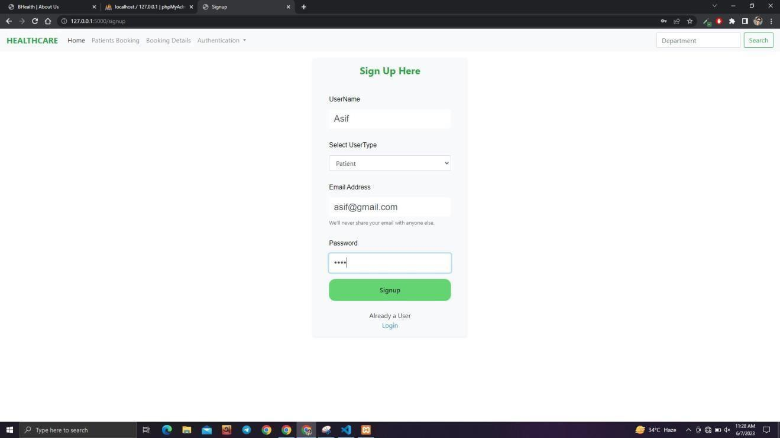

Fig 01: User interface

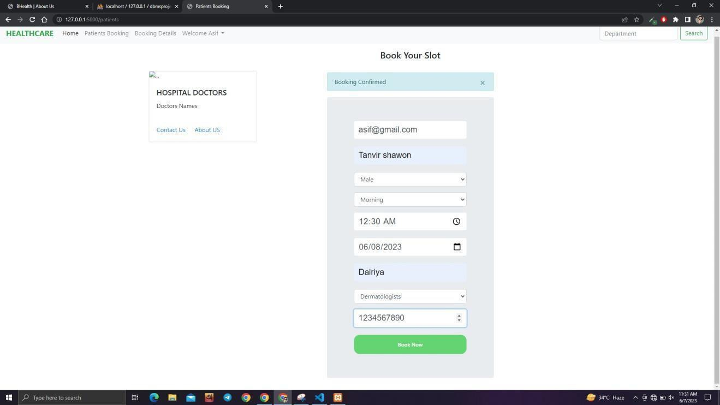

Fig 02: User interface

* + **Input output demo:**

## Future Scope and Limitation

* + **Limitation:**
  + **Future Scope:**
  + **Conclusion:**